**DAILY ONLINE ACTIVITIES SUMMARY**

|  |  |  |  |  |  |  |  |  |
| --- | --- | --- | --- | --- | --- | --- | --- | --- |
| **Date:** | **30/06/2020** | | | | | **Name:** | **POOJA D S** | |
| **Sem & Sec** | **IV sem & B section** | | | | | **USN:** | **4AL18CS056** | |
| **Online Test Summary** | | | | | | | | |
| **Subject** | | **-** | | | | | | |
| **Max. Marks** | | **30** | | **Score** | | | **-** | |
| **Certification Course Summary** | | | | | | | | |
| **Course** | **Introduction to Programming** | | | | | | | |
| **Certificate Provider** | | | **Great learning academy** | | **Duration** | | | **5.5hours** |
| **Coding Challenges** | | | | | | | | |
| **Problem Statement1:** Write a C++ Program to Move all zeroes to end of array using Two-Pointers.  **Problem Statement2:** Write a C Program to generate first n Ugly Numbers.  **Problem Statement3:**  Write a C Program to check whether the number is Ugly or not. | | | | | | | | |
| **Status: Executed** | | | | | | | | |
| **Uploaded the report in Github** | | | | | **YES** | | | |
| **If yes Repository name** | | | | | <https://github.com/dspooja/C-coding> | | | |
| **Uploaded the report in slack** | | | | | **YES** | | | |

Online Test Summary: No internals conducted today.

Online Certification Course Summary: In today’s session I have about Dictionary in Python, Set in Python, If Statement in Python, Looping

Statement in Python.

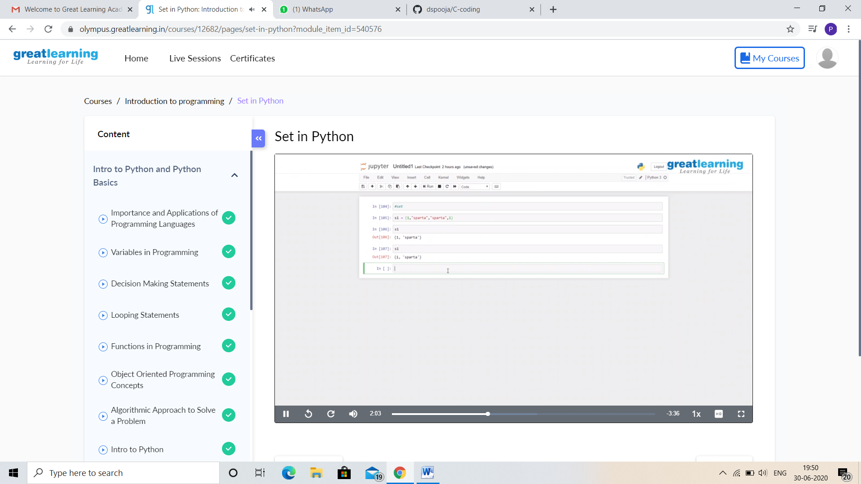

This is the snapshot of today’s session.

I Participating in the Webinar “DESIGN CONTROL APPLICATION” on 26th june.

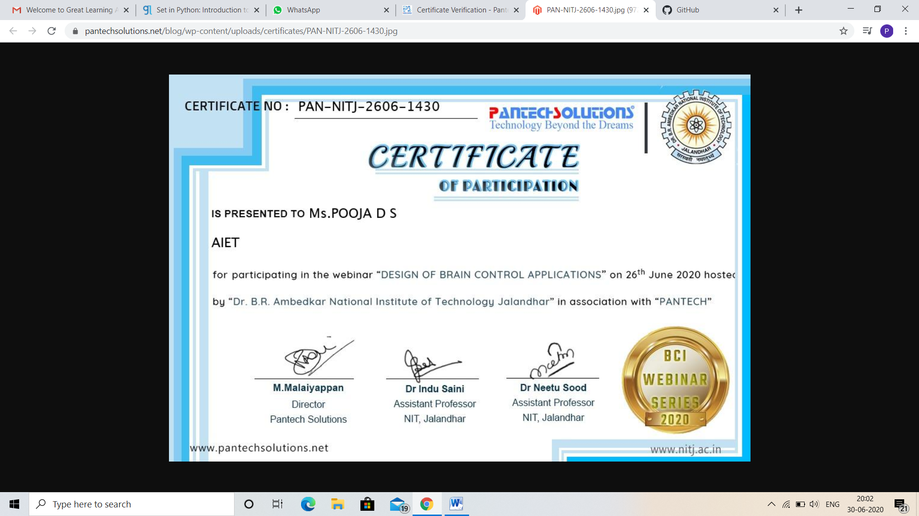

Online Coding Summary: **Today I had received programs from prof. Shilpa CSE Dept. and Prof. Venkatesh CSE Dept. The programs are mentioned above in the coding challenges (pg.01). I have also uploaded them to my Github repository.**

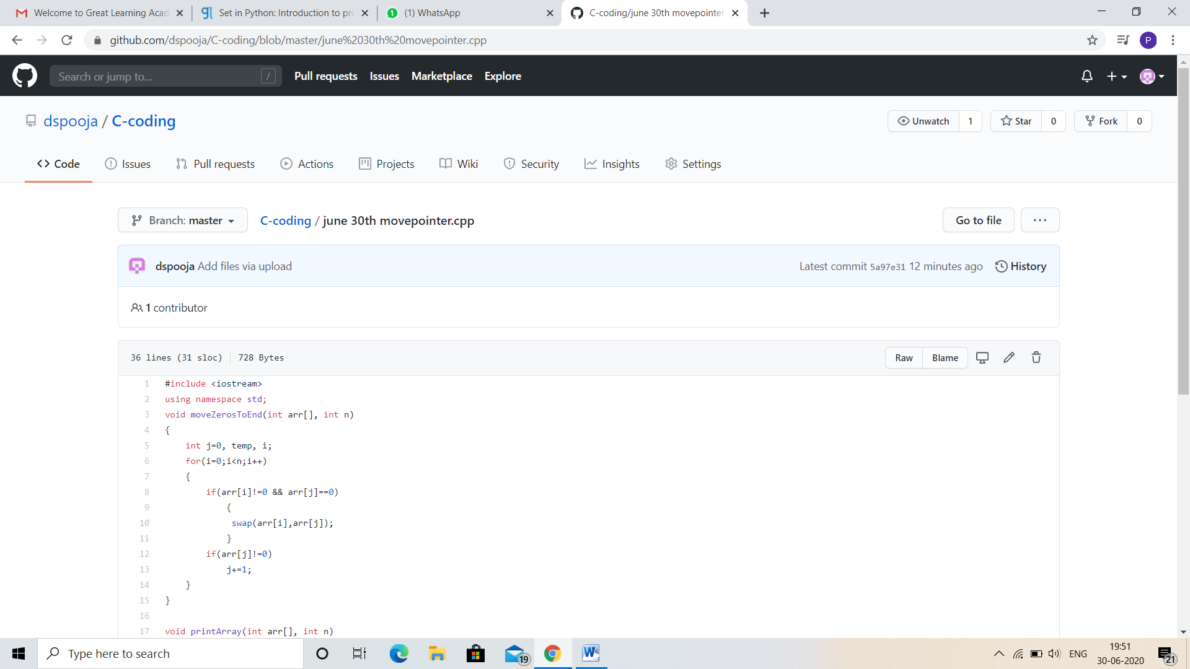

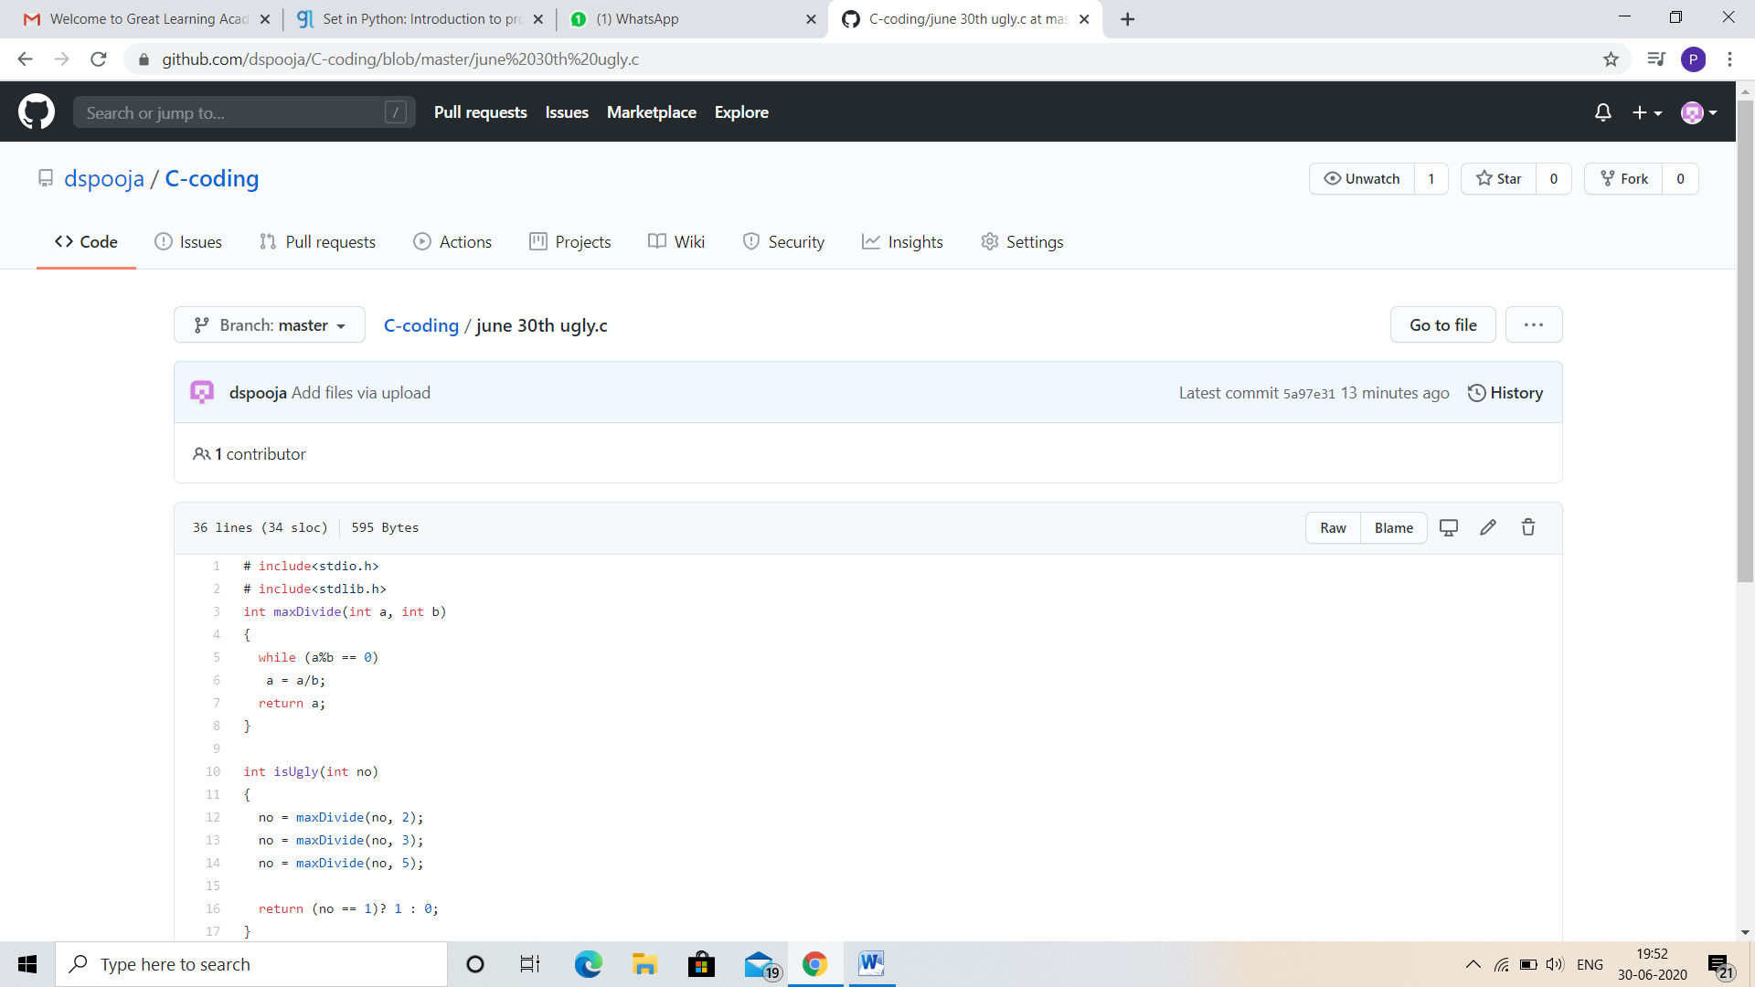

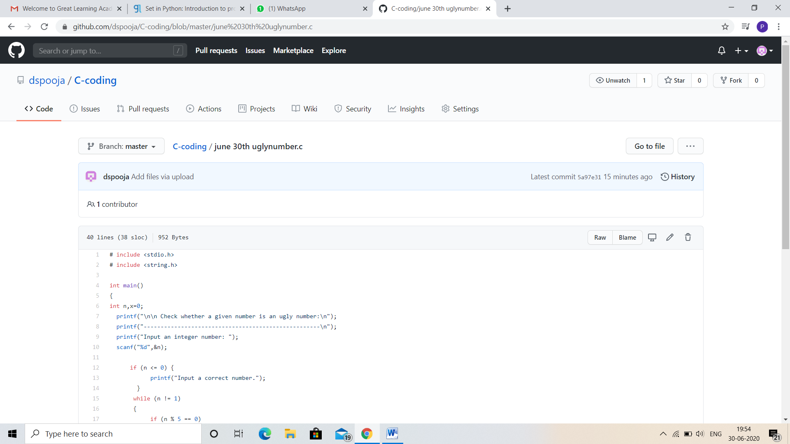

**This is the snap shot of my Github repository** were I have uploaded the code. File name is movepointers.cpp, ugly.c and uglynumbers.c

Online Training: Today I had attended the online training organized by CSE Department AIET. The training was on C++ programming language done by Prof. Shruthi Shetty J. CSE Dept. After the session the quiz was conducted.

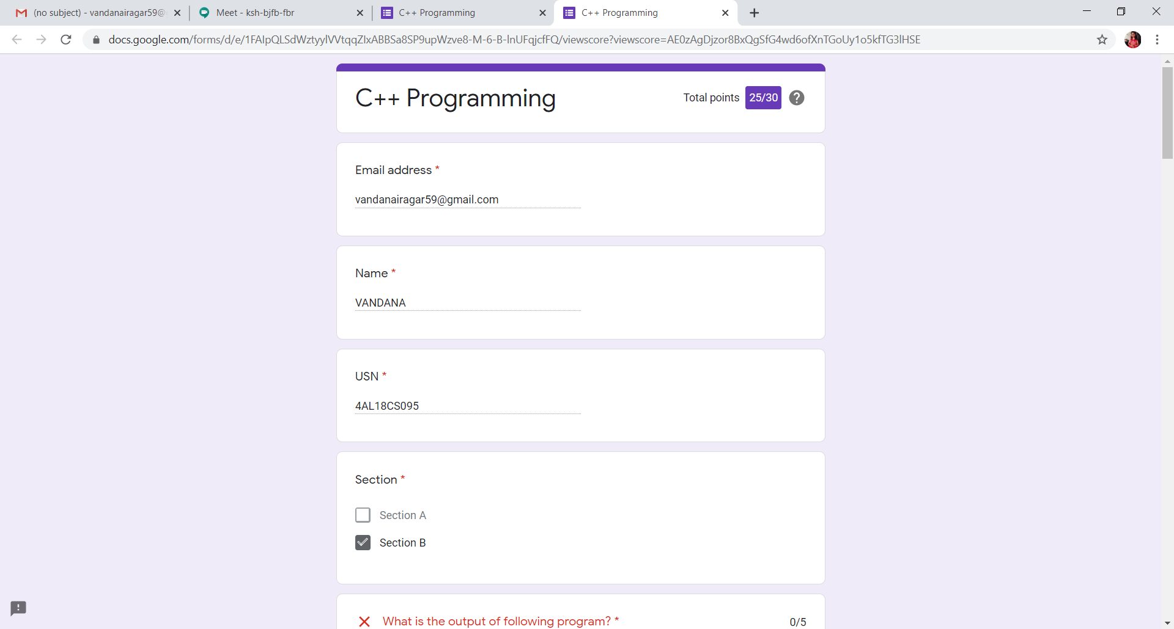

**This is the snap shot of the quiz attempted and scores obtained.**